**D2 – Evaluate the design and performance of a control system**

**Introduction**

In this report, I will evaluate the design and performance of a control system we created together as a group. I will evaluate each of the processes that we went as a group. I will name the roles of each person in my group and how we lead to build the robot and what we did after that as well.

We had 4 students within the group including myself and the names within the group were Hubert, Mohammed and Sohail. We all did the ‘REPTAR’ and each of our group members had different roles within it. My role was to get all the pieces together for the group. This was very important for any group because if I got a wrong piece and put it on, the robot would be wrong and later on we realise it, we have to take all the robot apart to fix it. Therefore, it is important I had a role. Hubert’s role in the group was to put the pieces that I provide him to put it together by using the guide. His role was important as he followed the manual to build the robot. Mohammed’s role was to take pictures. It sounds simple, but it is very important because we need to put the images that Mohammed has taken and put it into our work for later on. Sohail’s role was to find the pieces that were missing from out box. These roles were not fixed. Occasionally, we swapped roles and even if any of our members were absent, one of us took both roles to finish it off.

These roles that has been named above were set to each individual. We chose do tackle the hard the robot as we knew that it would take a very long time to build and program it. We had to make sure that we did not lose the small pieces that were put together and were needed to put together. We put it into a small box to make sure that not of the pieces go missing. We used a manual for each step and followed it. If anything went wrong, we went back and fixed it to make sure everything is working. It took only 4 lessons to build and I think that is pretty quick considering how long others took on it.

One problem we could of changed is that one of us could of started the theory part which we done later on once we did the robot. I would have changed it to start the pseudo code and storyboard of our robot. This would be start off the assignment and do the robot at the same time.

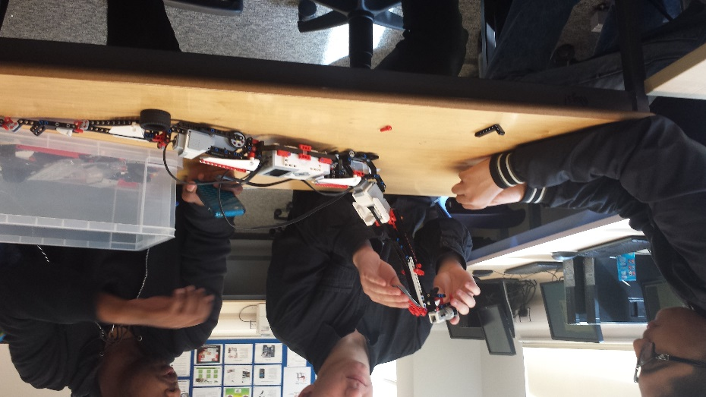Once we created the robot, we added an additional sensor to the robot. It was the ‘touch sensor’ and we programmed it to stop and only attack once it has been pressed. I programmed the sensor for it to work. It took longer than expected because they was no manual and instructions to program and build the additional sensor.

In addition, we gave a number of tests so we are fully satisfied that it functioned properly.

It created many problems without any manual for the additional sensor, but in the end, we fixed it and it worked. We programmed it by connecting a USB cable with the controller and a software to 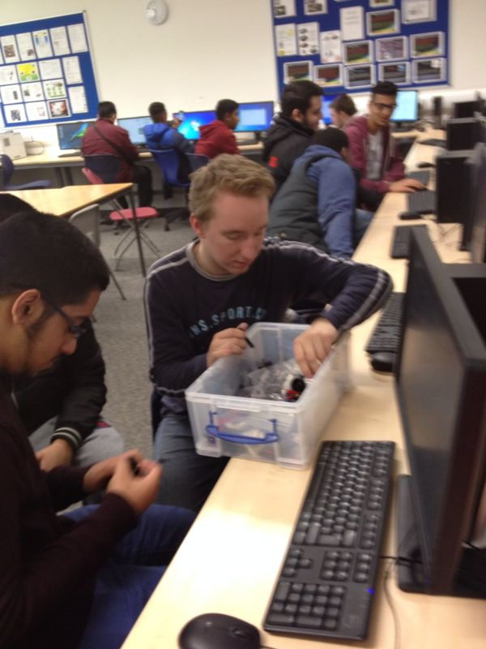complete the process. To run it, we needed to click ‘download and run’ and the program would work. However, if it did not work, we would realise and try again for it to work. We did it this several times, but in the end, it worked. I added the ‘infrared sensor’ program and the ‘walking’ with the waiting and putting it all together, it worked.

I and Mohammed created the storyboard and pseudo code for the robot. This was supposed to be done before the robot, but we decided to get the robot done and programmed and we did this after it. They were no errors that were detected whilst we did the test plan, however if they were, we would of went back and fixed it anyway. This was checked by all of the members in our group.

The big issue whilst we did this is that one of our members who had dealt with this before was absent. I had to step in and solve the program, because it was hard and it was the first time I had dealt with it. I found it important to solve this problem because we had to do the touch sensor which had no manual with it. This was the biggest problem we had to solve, but as a group, we did it and it was important we did.

This report has given us many problems to solve whilst we completed this robot. However, as a group, we did it together, fast and efficiently. Overall, I think that the group worked together very well. An example as I have named before was when one member was missing, one of us would step up and do the job for them. This was important for any group as if this did not happen, the group would be working slow and take time to complete the robot. One of the strong points of working together is that we all did our part for the theory work. Each of us did the part that they were set and we did it quickly in other for it to be complete. We had to work together for some of the criterions and I think we did that very well. For example P6 and D1, P6 was done by Aden, Sohail and myself.

